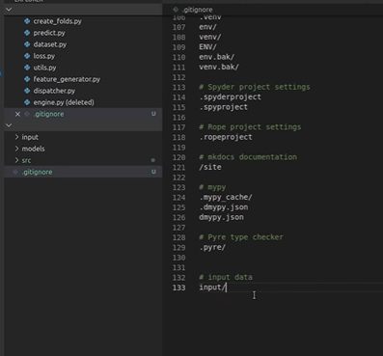

Create_folds.py

Predict.py

Dataset.py

Loss.py

Utils.py

Feature__generator.py

Dispatcher.py

.gitignore

Engine.py

Cmd:

Mkdir

